

Inspection Report

16 June 2023
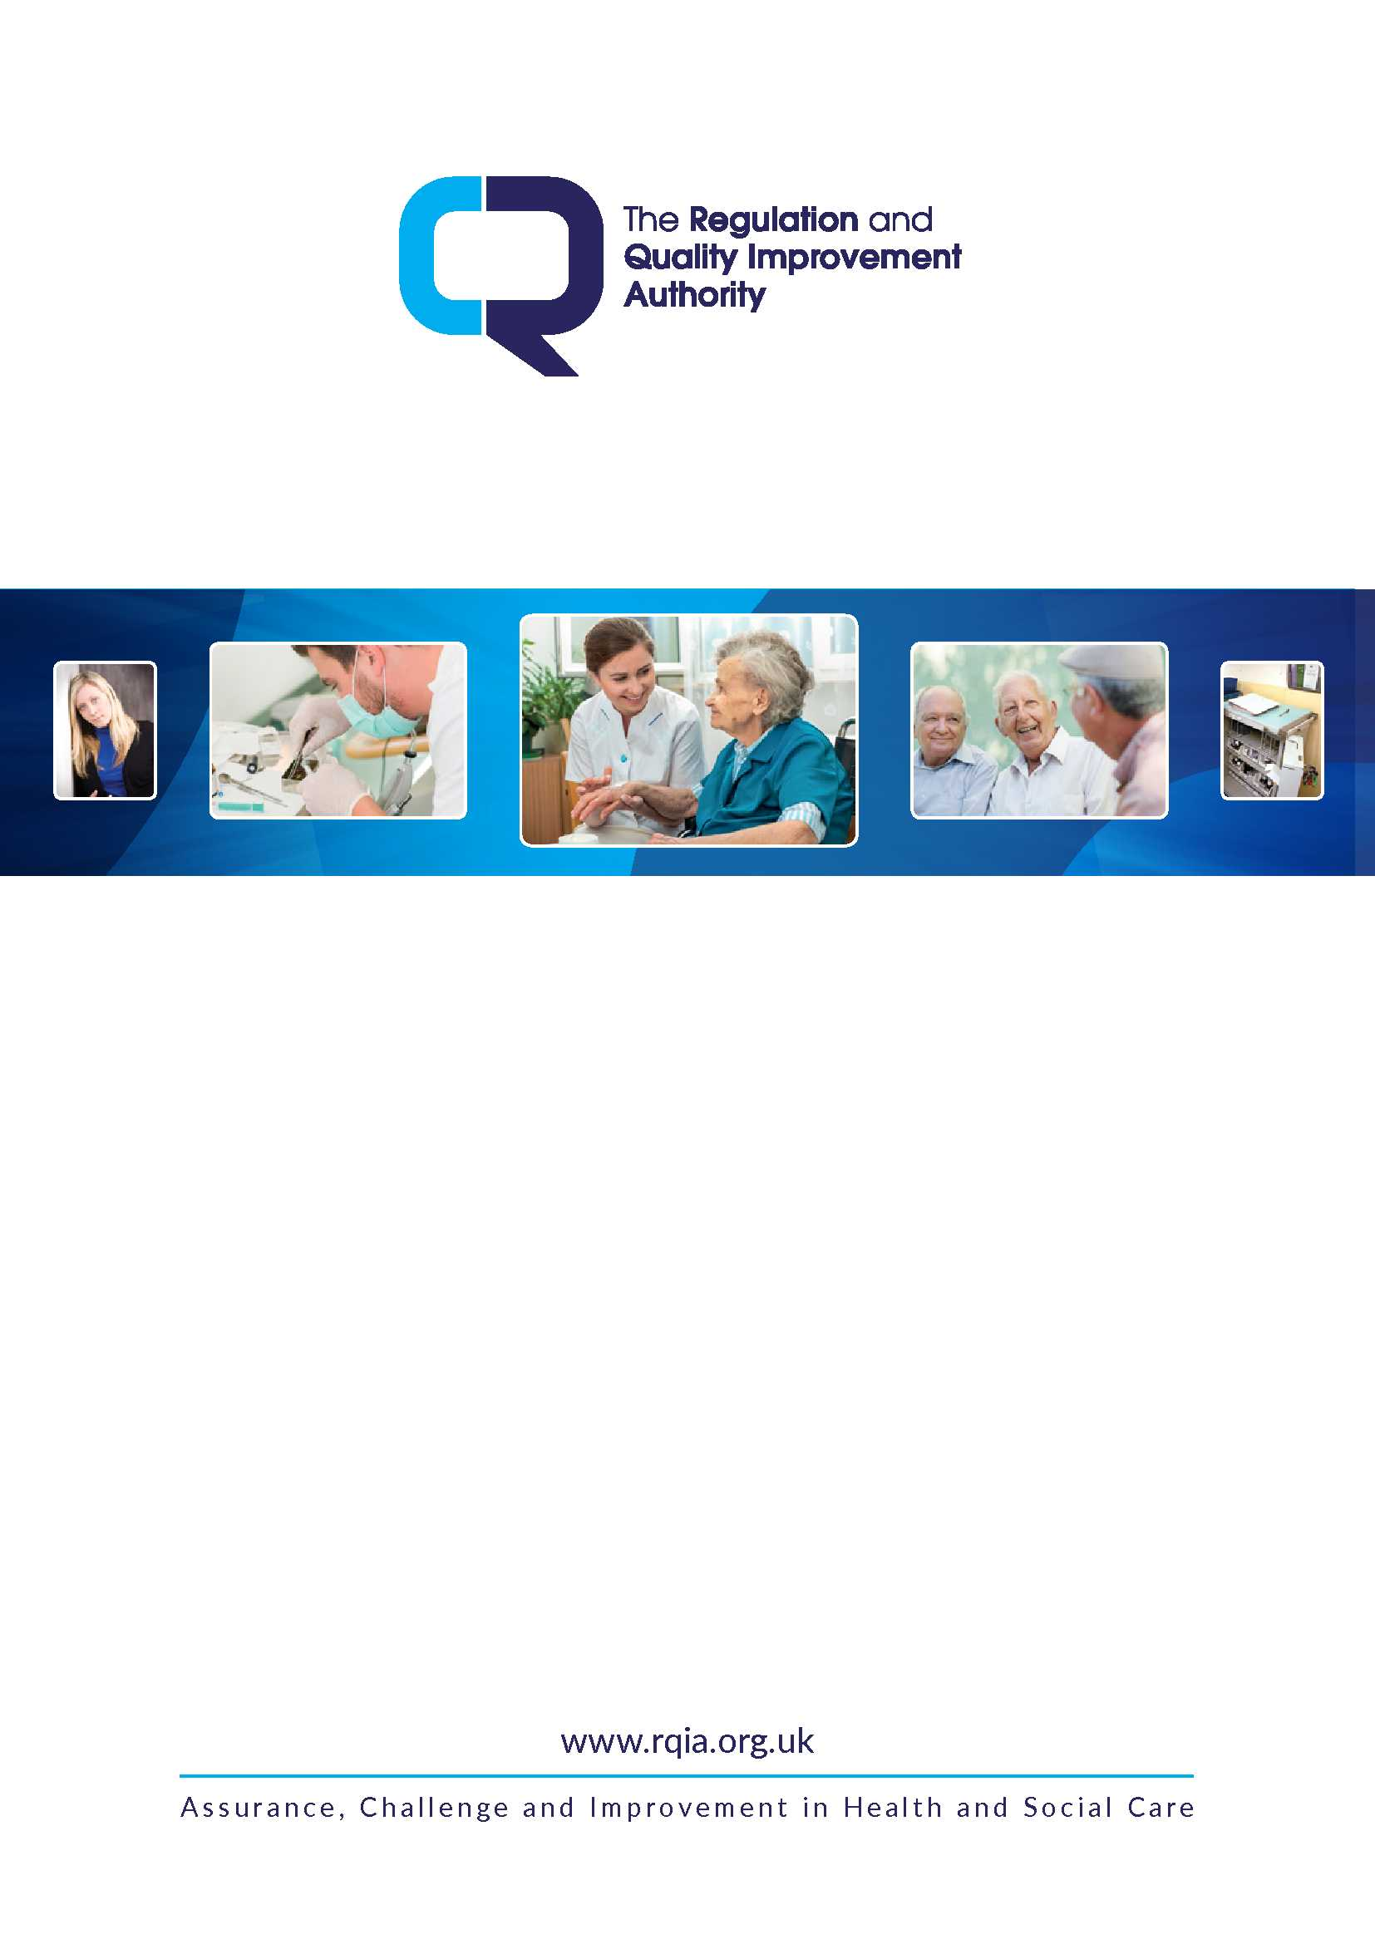
Positive Futures Families Matter
Shared Lives Service

Type of service: Adult Placement Agency
Address: Castleton Centre, 30a – 34a York Road, Belfast, BT15 3HE
Telephone number: 028 9074 1271

Information on legislation and standards underpinning inspections can be found on our website https://www.rqia.org.uk/

1.0 Service information

Organisation/Registered Provider:  Positive Futures  Responsible Individual:  Ms Agnes Philomena Lunny | Registered Manager:  Mr Paul Roberts  Date registered:  Acting
Person in charge at the time of inspection:
Mrs Julie McDowell, Service Manager

Brief description of the accommodation/how the service operates:

Families Matter Shared Lives Service offers people with a learning disability, acquired brain injury or autistic spectrum condition short breaks or longer stays with approved individuals or families who are known as Shared Lives Carers.

The agency has placed 25 people supported by 27 Adult Placement Carers.

2.0 Inspection summary

An announced inspection was conducted by the care inspector on 16 June 2023 between 9.25 a.m. and 3.00 p.m.

Positive Futures Families Matter Shared Lives Service uses the term ‘people who we support’ or ‘people supported’ to describe the people to whom they provide care and support. For the purposes of the inspection report, the term ‘service user’ is used, in keeping with the relevant regulations.

This inspection focused on carer recruitment and induction, adult safeguarding, notifications, complaints, whistleblowing, deprivation of liberty safeguards (DoLS), service user involvement, monthly quality monitoring and Dysphasia.

Good practice was identified in relation to service user involvement and the arrangements to monitor and maintain quality; this was underpinned by good management and governance arrangements and clear lines of communication between all parties. Staff and adult placement carers who spoke with us demonstrated strong caring values and were familiar with the choices and preferences of service users. It was evident that this resulted in good quality, personalised care.

No areas for improvement were identified.

The inspector would like to thank the manager, staff, service users and APA carers for their support and feedback during the inspection.
3.0 How we inspect

RQIA’s inspections form part of our ongoing assessment of the quality of services. Our reports reflect how they were performing at the time of our inspection, highlighting both good practice and any areas for improvement. It is the responsibility of the service provider to ensure compliance with legislation, standards and best practice, and to address any deficits identified during our inspections.
As a public-sector body, RQIA has a duty to respect, protect and fulfil the rights that people have under the Human Rights Act 1998 when carrying out our functions. In our inspections of adult placement agencies, we are committed to ensuring that the rights of service users are protected. This means we will seek assurances from providers that they take all reasonable steps to respect the dignity and privacy of service users whilst promoting independence and autonomy to experience the choices and freedoms associated with any person living in their own home.
“We Matter” Adult Learning Disability Model for NI 2020 states, ‘We want individuals with a learning disability to be respected and empowered to lead a full and healthy life in their community’. RQIA shares this vision and seeks to ensure individuals are offered choices and decisions to enable them to develop and to live a safe, active and valued life.

The inspection focused on:

- consultation with service users, the APA carers and the agency manager to find out their views on the service
- review of a range of relevant documents, policies and procedures relating to the agency’s governance and management arrangements.

4.0 What people told us about the service

We spoke with a selection of APA carers prior to the inspection. Information was provided to APA carers and service users on how they could give feedback on the quality of service provided and this included questionnaires. Two questionnaires were returned in which people stated that they were either satisfied or very satisfied with the service provided. Carers’ outcomes were consistently good, and their feedback confirmed this. We also had the opportunity to meet a person supported at the agency office during this inspection and have included the comments received:

Service user’s comments:

- “I have a great time when I am with my carers, we get out and about and we do thing together which I really enjoy.”

Carers’ comments:

- “I have been involved with Positive Futures for a long time…we have a formal agreement in place so our roles and responsibilities are well understood…I got a good induction and have completed training…the agency staff monitor the placement very closely. I know who I can contact at any time if I have concerns and I am fully assured that I have the support of staff. Positive Futures has helped me enormously; they are always available for advice and any training I might need. Anything I have asked for, I have been given and I know staff will help me. I have no complaints but know they are on the end of the phone if I need them.
I get invited along to social events and this is important as I get to meet with other people who are carers. I can’t speak highly enough of the Positive Futures team.”
- “I am offered regular training and the quality of the training is very good, it is pitched at exactly the right level for us adult placement carers. Positive Futures makes sure the training is kept up to date. Positive Futures is an excellent organisation, just wonderful, and the people they support are in good hands. Staff are extremely supportive and approachable and can be contacted at any time, so carers feel very well supported…we all get the regular newsletter and this helps us feel included and involved. The experience of being a carer has so enriched my life…I can’t commend Positive Futures highly enough!”
- “Positive Futures is a brilliant service. The staff are very helpful and supportive. I have no problems getting training and resources…we get a newsletter which keeps us informed of what is happening. The staff are in close contact and are very attentive…I know I can contact them if I need to.”

5.0 The inspection

5.1 What has this service done to meet any areas for improvement identified at or
since last inspection?

The last inspection to Families Matter Shared Lives Service was undertaken on 19 May 2022 by a care inspector; no areas for improvement were identified.

5.2 Inspection findings

5.2.1 Are there systems in place for identifying and addressing risks?

The agency’s provision for the welfare, care and protection of service users was reviewed. The organisation’s policy and procedures reflected the Department of Health’s (DoH) regional policy ‘Adult Safeguarding Prevention and Protection in Partnership’ July 2015 and clearly outlined the procedure for staff in reporting concerns. The organisation had an identified Adult Safeguarding Champion (ASC). The Adult Safeguarding Position report for the agency was reviewed and found to be satisfactory.

Discussions with the person in charge demonstrated that they were knowledgeable in matters relating to adult safeguarding, the role of the ASC and the process for reporting adult safeguarding concerns. Carers were required to complete adult safeguarding training during their induction programme and updates thereafter in line with legislation and draft standards.

Staff and carers had a clear understanding of their responsibility in identifying and reporting any actual or suspected incidences of abuse. They could describe their role in relation to reporting poor practice and their understanding of the agency’s policy and procedure with regard to whistleblowing. The agency had a system for retaining a record of any referrals made to the HSC Trust in relation to adult safeguarding.

Service users who spoke to us stated that they had no concerns regarding their safety; they described how they could speak to staff if they had any concerns in relation to safety or the care being provided. The agency has provided service users with information in relation to keeping themselves safe and the details of the process for reporting any concerns.

There were systems in place to ensure that notifiable events were investigated and reported to RQIA or other relevant bodies appropriately. It was noted that incidents had been managed in accordance with the agency’s policy and procedures.

The manager and staff demonstrated that they had an understanding that service users who lack capacity to make decisions about aspects of their care and treatment have rights as outlined in the Mental Capacity Act (MCA). The MCA requires that, as far as possible, service users make their own decisions and are helped to do so when needed; any decisions made on their behalf must be in their best interests and as least restrictive as possible. MCA training had been completed by all carers as part of their induction programme.

Staff had completed Deprivation of Liberty Safeguards (DoLS) training appropriate to their job roles and carers had been provided with awareness training. Where service users were subject to DoLS, the required documentation was in place and was kept under regular review.

5.2.2 What are the systems in place to ensure robust Carer recruitment?

A review of records evidenced that recruitment was completed in conjunction with the organisation’s Human Resources (HR) department. The records confirmed that recruitment was managed in accordance with the Regulations and Minimum Standards; criminal record checks (AccessNI) had been completed for all current carers.

5.2.3 People supported involvement.

RQIA was assured that service users were central in directing their care plans as far as possible. This was confirmed by service users, carers and staff. Easy read reports were provided which allowed service users to fully participate in all aspects of their care. The service users’ care plans contained details about their likes and dislikes, the level of support they required and how this should be delivered; annual reviews of care were signed by service users, their family or representative or by an advocate. Care plans and associated risk assessments were noted to be written in a professional and respectful manner which promoted the dignity and confidentiality of the service user and all other relevant parties.

There were enough carers to make sure people received the support they needed, including facilitating their chosen activities.

The agency completed an annual quality review which gave service users, families, carers and HSC Trust staff opportunity to comment on the service. The report noted feedback which was overwhelmingly positive:

Feedback from service users:

- “I love living here.”

- “(My relative) has a great relationship with the (carers). Communication is excellent…. (he) enjoys visiting the (carers) and often talks about his visits…(he) enjoys walking their dog and playing in the big garden.”

- "(Service user) attends day centre and appears to be settling in well…(she) shows no indication that she is unhappy within this placement.”
- “I like everything (about my placement).”

- “I am always happy when I’m there.”

- “I love both carers. They are very kind to me.”

- “They are family to me.”

- “They have made me feel safe all my life.”

- “I always feel safe and happy.”

- “I love my carers and all the staff, they help me do everything.”

- “I am treated no different than the carer’s children.”

- “I love going on my holidays.”

- “I need the service for me to be able to live with my carers.”

- “Communication is excellent. Good relationship with staff team.”
Feedback provided by carers:

- “If we need any help staff are always there. We have had a hard year and they have helped us a lot.”

- “Staff at Share Lives are always at the end of the phone when you need them.”

- “This is an excellent service.”

- “The Short Term Carers are fantastic. When I was in hospital they were a great support.”

- “He loves going and is welcomed with open arms.”

- “They always do things he enjoys and try different activities with him.”

- “The carers help him to do activities he wants. The staff at the service are great.”

- “The carers were sick and couldn't take my son out at Christmas to the Enchanted Garden so the staff did.”

- “I am unable to take my (relative) out shopping, walks, days out and have fun. So I know she is getting a lot out of your service.”

- “I know that I can make a call to the office and make arrangements with no problems. I also know that staff (2nd family) contact us if any is different or circumstances change.”

- “There is nothing I could want from the service than I already receive. The package we have are responsible, family, kind, happy, patient people so this is a lifeline to us. Thank you!”

- “I can't think of anything you could do any better. The families we have are truly genuine guardian angels!”
- “I would say Positive Futures staff go above and beyond what would be expected of them for the people we care for.”

- “All support, communications, home visits are carried out to the highest standards.”

Feedback provided by HSC Trust:

- “Flexible and provide good support to clients who can display complex behaviour.”

- “Communication is excellent. Good relationship with staff team.”

- “Staff are very engaging and efficient.”

5.2.4 What are the arrangements for the induction of Carers?

The manager confirmed that an induction programme was available for newly recruited carers. This document was reviewed and found to comprehensively meet the induction requirements in line with regulations and the draft standards.

5.2.5 What are the arrangements to ensure robust managerial oversight and governance?

There were monitoring arrangements in place in compliance with regulations and draft standards. Records reviewed showed that monitoring visits were undertaken on a regular basis. This was where an agency staff member visited a carer’s home when the service user was present, so that daily tasks could be observed in order to verify that carers were meeting the required standards. Reports relating to the agency’s monitoring visits were reviewed and found to be robust.

The provider had ensured that the quality assurance systems in place were effective in achieving positive outcomes for service users. The was a system of internal audits and an annual satisfaction survey where feedback from service users, their carers and other stakeholders was sought. The feedback was incorporated into the annual quality report, as described above.

5.2.6 What are the arrangements in place for Carer training?

Carers consulted with prior to the inspection spoke positively about the variety and level of training they had received to enable them to fulfil the duties and responsibilities of their role. Carers described training as being of a good standard.

A review of the agency’s training records confirmed that carers had received mandatory and other training relevant to their roles and responsibilities throughout 2022 and 2023; where training was slightly out of date, there were firm plans for this to be completed.

5.2.7 Is there a system in place for identifying service users’ Dysphagia needs in partnership with the Speech and Language Therapist (SALT)?

The manager confirmed that the agency had received a number of specific recommendations from Speech and Language Therapy (SALT) in relation to current service users. Records in place were reviewed and were satisfactory. A review of training records confirmed that Carers were provided with Dysphagia/swallowing awareness training.

6.0 Conclusion

Based on the inspection findings and discussions held, RQIA was satisfied that this agency was providing services in a safe, effective, caring and compassionate manner and that the service was well led by the management team.

This inspection resulted in no areas for improvement being identified. Findings of the inspection were discussed with Mrs Julie McDowell, Service Manager, as part of the inspection process and can be found in the main body of the report.

